

**TABLE OF CONTENTS**  


**Introduction** **3**

**Requirements** **4**

**User Interface** **5**

**Project Plan** **17**

**Conclusion** **18**

**References** **19**

# Introduction

App Icon:



App Name:uCollect

Our application uCollect will enable to collector to catalogue their collections at their convenience.The application will allow for the easy creation of collections in which the user can add or remove items in their collections.The goal of the application is create a user friendly platform for users to create and store a record of all their collections. The platform will also encourage collectors to connect with their peers and view public collections or share their own collections. This will create an environment for like minded individuals to connect via their common interests.

Innovative features include:

QR Code scanning to add friends in the application

# 

# Requirements

System Requirements

* Create a user friendly application
* Access to all the device-specific features, including GPS, camera, gestures, and notifications.
* Ability to function with and without an internet connection
* Functionality on a majority of Android devices
* Create user profiles
* Login using password and username
* Create a collection or multiple collections
* Create collection categories e.g a Shoe category for all shoe related collections
* Set a goal of how many items a complete collection has.
* View how many items of a specific collection are outstanding and have a progress bar indicating the percentage of the collection that is complete
* Add new items to a collection with information such as, description of item,date of acquisition and the category
* View a list of the complete collection
* Add existing images of an item or take a picture of an item that will be stored
* View a graph showing the percentages of items in each category
* Create a visual presentation of the percentage in which certain categories have complete collections
* Store all data in an online database

# 

# User Interface

Include flow diagram of app after meeting

shorturl.at/vBNUY

[Mockup link](http://shorturl.at/vBNUY)

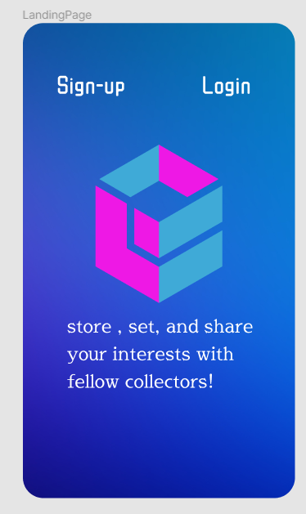

Landing page

When the user opens the application, this is the first page they will see, which gives the option to sign-up or log in to the application with an existing account.

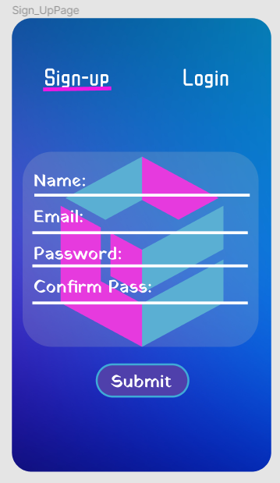

Sign-Up Page

If the user selects Sign-up they will be prompted to enter their: name, email address and password.The password will also be confirmed before the account is created ,upon pressing Submit.

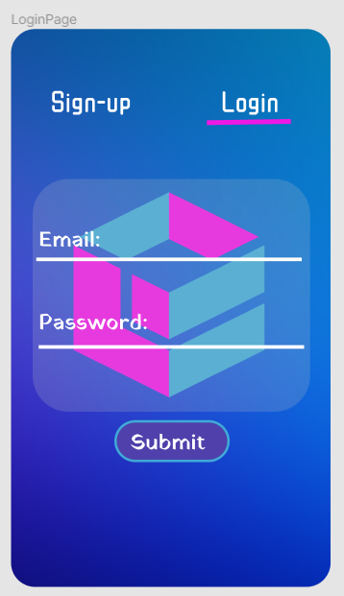

Login Page

When the user selects Login, they will be prompted to enter their email and password to login to an existing account.

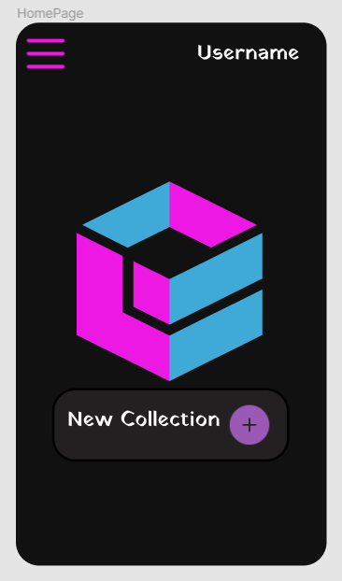

Home page

Once a user has successfully logged on or created an account they will be brought to the home page where they can either browse their collections or create a new collection.

Their username will be displayed on the top right corner of the application and on the left corner they will have access to more options.

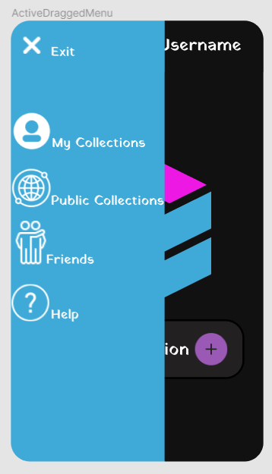

More Options

The user will be presented different options to navigate to namely:my collections,public collections,friends and help.

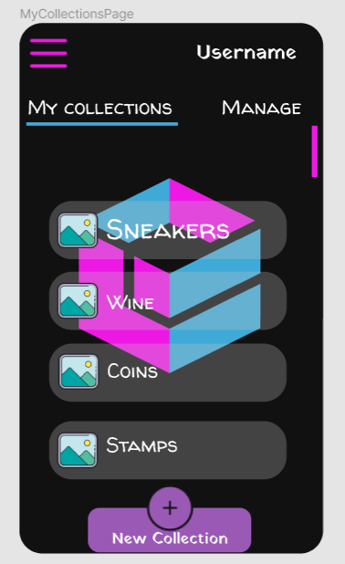

My collections page

The user will be able to view all their existing collections and create new collections.

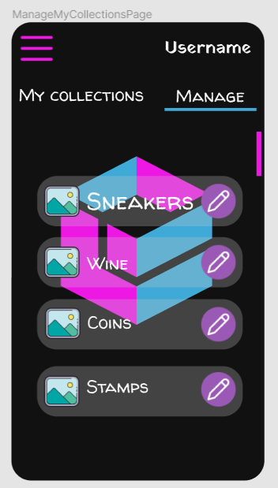

My collections page

By shifting to the manage tab on my collections the user will be able to modify or delete a collection.This can be done by clicking on the pencil icon.

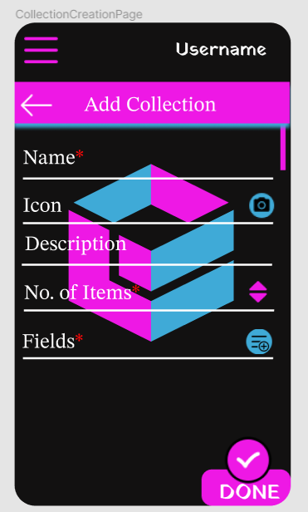

Add Collections Page

After clicking add collections the user will be prompted to enter details pertaining to their collections namely:Collection name,icon or picture, description,the total number of items in a complete collections,fields,

After completing the form, the user will click on done and a new collection will be created

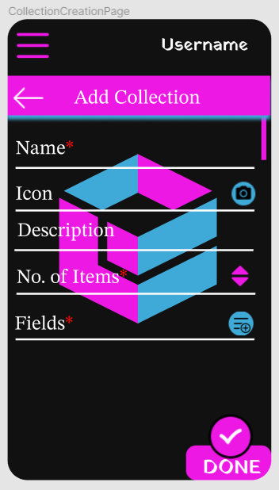

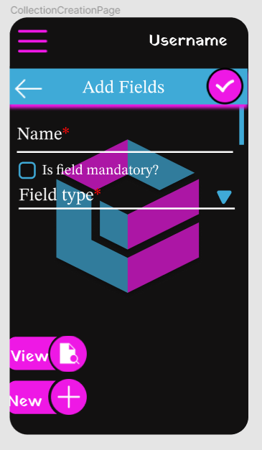

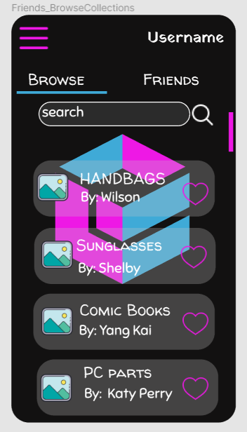

Public Collections

On this page the user can view the public collections of other users within the platform and click on the heart icon to mark particular public collections as their favourites.

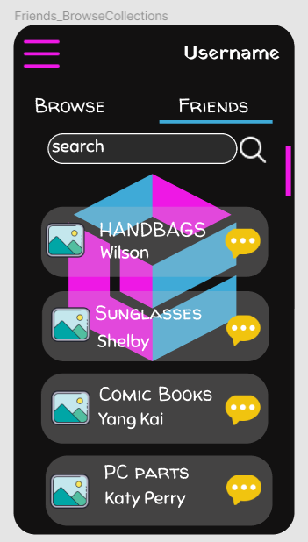

Public Collections

By shifting to the tab on the right titled ‘Friends’ the user is able to send messages to other collectors across the platform.

# 

# Project Plan

shorturl.at/jpGH6

[Gannt Chart link](http://shorturl.at/jpGH6)

P

| 1.1 | Identify the problem | Whole team |
| --- | --- | --- |
| 1.1.1 | Identify system requirements | Cynthia |
| 1.2 | Investigate existing systems | Odirile |
| 1.3 | Identify possible features | Tumelo |
| 1.4 | Group features | Owen |
| 1.5 | Assign roles | Whole team |
| 1.6 | Design the logic of the GUI | Keamogetsoe |
| 2.1 | Design the logic of the Database | Owen |
| 2.2 | Design program logic | Tumelo |
| 2.3 | Create the UI | Odirile |
| 2.4 | Create a mock database | Owen |
| 2.5 | Develop the business logic | Cynthia |
| 3.1 | Review the database | Odirile |
| 3.2 | Review the UI | Whole team |
| 3.2.1 | Review the business logic | Keamogetsoe |
| 3.2.2 | Adjust the code | Owen |
| 3.3 | Unit test all the sections | Keamogetsoe |
| 3.3.1 | Resolve issues found in the tests | Odirile |
| 4.1 | Test the application | Tumelo |
| 4.2 | Resolve all issues found in the test | Cynthia |
| 4.3 | Evaluate the program | Whole team |
| 4.4 | Conduct final test | Whole team |

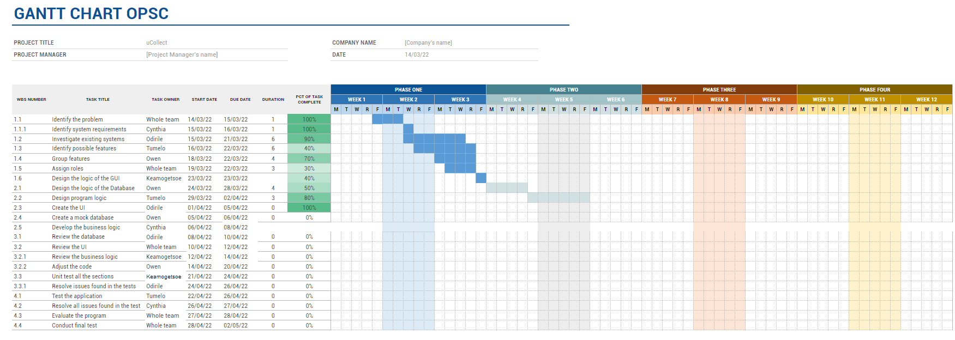

# 

# Conclusion

The application, uCollect, will be created with the user in mind, making their user experience as exemplary as possible.The application is designed to cater to the needs of collectors and will be made to foster an environment in which collectors can have access to their collections at the touch of a button.We also understand the joy of sharing collections with like minded individuals and thus will create a platform where collectors may converse among each other regarding all things related to their collections.

# 

# References

Ibm.com. 2022. *IBM Docs*. [online] Available at: <https://www.ibm.com/docs/en/spm/7.0.11?topic=requirements-defining-mobile-application> [Accessed 13 March 2022].  
  
  
  
  
  
  
  
  
  
  
  
  
  
  
  
  
  
  
  
  
**MY LITTLE STORY  
**

Lorem ipsum dolor sit amet, consectetur adipiscing elit. Curabitur viverra auctor purus in tempor. Integer vulputate suscipit orci, sit amet tristique metus fringilla sit amet. Integer sit amet sapien at leo maximus placerat ac at diam. Donec vestibulum mattis magna, quis blandit purus tincidunt non. Integer urna diam, sollicitudin consequat orci suscipit, consequat pharetra justo. Nullam nec turpis vitae risus auctor scelerisque a vel quam. Ut risus orci, tristique id erat vitae, auctor interdum augue. Ut lacinia fermentum diam ut mollis. Mauris viverra elit sit amet metus pretium lacinia. Aenean accumsan purus id turpis pulvinar, a tincidunt enim dictum. Aenean turpis urna, volutpat sit amet mattis quis, ullamcorper dictum ante. Donec vehicula sagittis diam. Suspendisse nec convallis nunc. Morbi eget dolor ut erat tincidunt vestibulum. Quisque bibendum ligula quis scelerisque bibendum. Nam at sapien sit amet justo dictum accumsan scelerisque ac nunc.



**STREET PHOTOS**

Lorem ipsum dolor sit amet, consectetur adipiscing elit. Curabitur viverra auctor purus in tempor. Integer vulputate suscipit orci, sit amet tristique metus fringilla sit amet. Integer sit amet sapien at leo maximus placerat ac at diam.  
  
Donec vestibulum mattis magna, quis blandit purus tincidunt non. Integer urna diam, sollicitudin consequat orci suscipit, consequat pharetra justo. Nullam nec turpis vitae risus auctor scelerisque a vel quam. Ut risus orci, tristique id erat vitae, auctor interdum augue. Ut lacinia fermentum diam ut mollis. Mauris viverra elit sit amet metus pretium lacinia. Aenean accumsan purus id turpis pulvinar, a tincidunt enim dictum.  
  
Aenean turpis urna, volutpat sit amet mattis quis, ullamcorper dictum ante. Donec vehicula sagittis diam. Suspendisse nec convallis nunc. Morbi eget dolor ut erat tincidunt vestibulum.  
  
Quisque bibendum ligula quis scelerisque bibendum. Nam at sapien sit amet justo dictum accumsan scelerisque ac nunc. Quisque vulputate dolor a urna tincidunt lacinia.

  
  
  
  
  
  
  
CONTACT ME  
[your@mail.com](mailto:your@mail.com)  
[www.yourwebsite.com](http://www.yourwebsite.com)  
www.facebook.com